Apply filters to SQL queries
Project description
In this scenario, I’m a security professional at a large organization. Part of my job is to investigate security issues to help keep the system secure. We recently discovered some potential security issues that involve login attempts and employee machines.
Our task is to examine the organization’s data in their employees and log_in_attempts tables. I need to use SQL filters to retrieve records from different datasets and investigate the potential security issues.

Retrieve after hours failed login attempts
To identify potentially suspicious activity, I filtered login attempts that were unsuccessful and occurred outside of standard business hours. This helps detect possible unauthorized access attempts during unusual times.

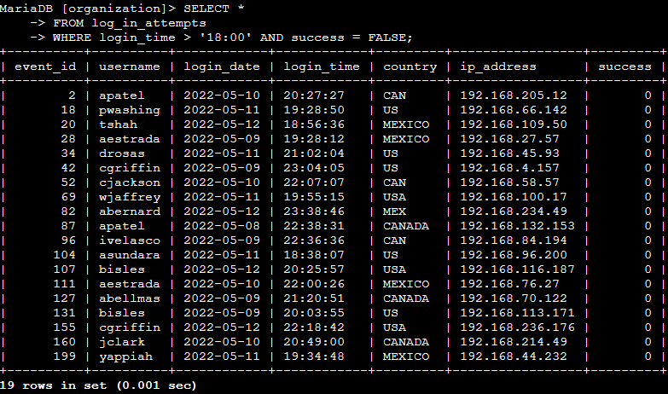

Retrieve login attempts on specific dates
To investigate activity on specific dates, I filtered login attempts using the login_date field. This allows focused analysis on days where potential security incidents may have occurred.
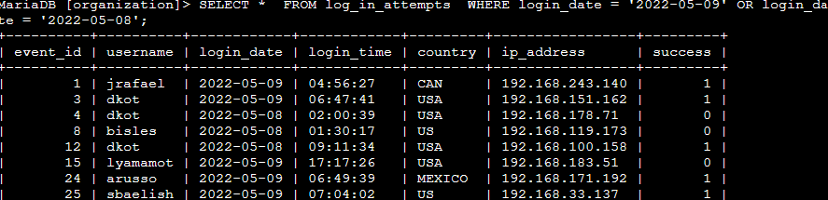

Retrieve login attempts outside of Mexico
To detect potentially suspicious access attempts from unexpected locations, I filtered records where the login origin was outside of Mexico.
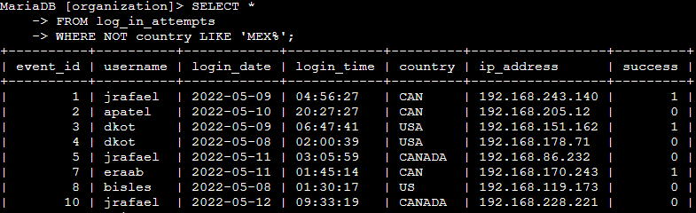

Retrieve employees in Marketing
To review employees within a specific department, I filtered the employees table by the Marketing department.
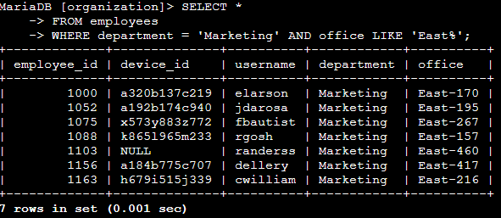
Retrieve employees in Finance or Sales
To analyze employees across multiple departments, I used a conditional filter to include both Finance and Sales.
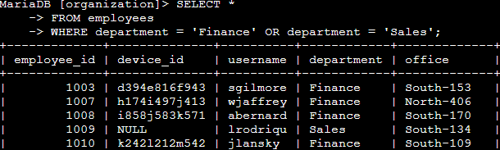

Retrieve all employees not in IT
To identify employees outside the IT department, I used a NOT condition to exclude IT staff.
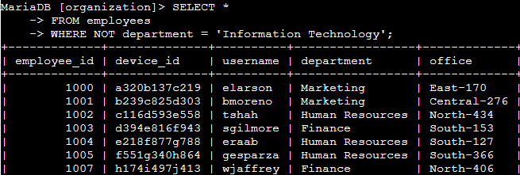

Summary
In this project, I used SQL filtering techniques to analyze employee and login data in order to investigate potential security concerns. By applying filters based on time, date, location, and department, I was able to identify suspicious login behavior such as failed attempts outside business hours and access from non-trusted locations. These techniques are essential in cybersecurity for monitoring activity, detecting threats, and supporting incident response efforts.

